1. **Research Problem:**

Students get their performance history in the form of

1. Grades
2. Weightage
3. Attendance
4. Etc

But data on their **personal learning** is lacking.

Personal learning through personal visualization for students so that they can evaluate themselves on basis of their own previous performances (data captured regularly and seamlessly etc).

Note: Personal visualization doesn’t improve students’ learning. It helps students’ improve their learning.

1. **Proposed Solution:** (Suggestions given practically not done)

Personal Data 🡪 Personal Visualization 🡪 Personal Learning

Personal data is dynamically and regularly updated which is displayed to students in a timely way. Such personal data can be presented to the student through personal visualizations (i.e. graphs, charts etc) that engender personal learning.

Personal Data Capture 🡪 Personal Learning Visualization

**Contribution of the paper:**

1. Empower the students with resources that enable them to learn better, based on their own data.
2. This is a two-way journey of the learners understanding themselves
   1. personally, their emotions, moods and sensations
   2. externally, the material world, events and circumstances

They raised some key questions regarding a personal learning mechanism.

1. How can we encourage and empower learners to become more conscious of their learning?
2. How can we deepen learner’s understanding of what they have learnt?
3. How can they adapt learning strategies to their own skill-set and style or see how well they are doing in comparison to others?
4. How can they plan, manage and qualify their learning?
5. How do we capture data – and what data – to help learners realize how they are progressing?
6. How can we assist students using visualizations that effectively depict their progress, learning context and results?

In order to answer the above questions, they organized the paper in four parts:

1. Provide background that gives context to the personal data for learning.
2. Highlight core related work.
3. Focus on our experience and explain some key projects that we have been involved with.
4. Develop a vision for personal learning visualization.

The aim is to motivate and excite the community to develop further the concept of personal datavisualization for learning

**Assumptions:**

Our vision is to

1. Place visualization at the heart of the learning environment (rather than an afterthought).
2. Put the users in control of their own learning experience.
3. Use a wide range of data as input.

We propose a tiered approach where most data is captured but some is predicted then visualized and used by students to develop their personal learning plan.

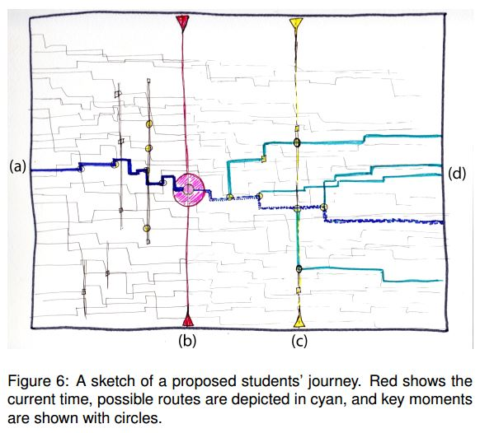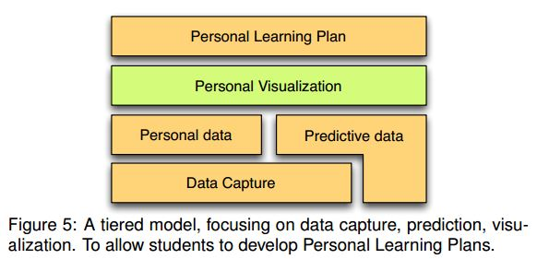

**Limitations:**

Potential challenges:

1. Some students may feel that this is too much of an intrusion into their own personal life and activities.
2. Consequently, data security and anonymization must be a priority.

**Evaluation Criteria:**